Week 5: Payment Transaction Management System Scenario:
The e-commerce company needs to maintain payment information for customer orders. The system should record payment details, track transaction status, manage successful and failed payments, and generate payment-related business reports.
Students will create a Payment Transaction Module connected with the existing Customer and Order Management modules.

Tasks to be Done:
1. Create Payment Table Payment Entity
Stores customer  payment transaction details. Attribute | Description
Payment_ID | Unique payment identifier
Order_ID | Order reference
Payment_Date | Date of transaction
Payment_Mode | UPI/Card/Net Banking/Cash
Payment_Status | Success/Failed/Pendi ng
Transaction_Amount | Paid amount

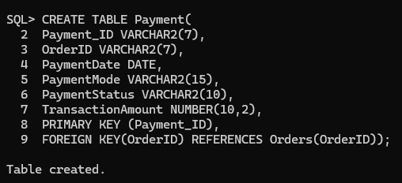

Store Payment Details
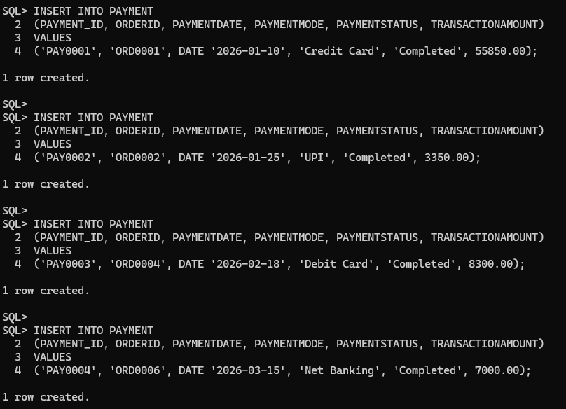

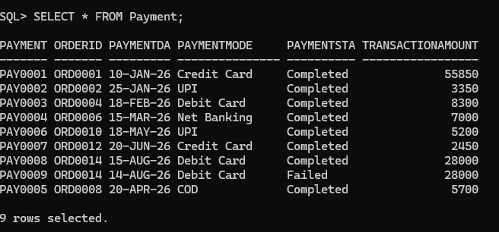

Manage Successful and Failed Transactions Tasks:
Write SQL queries to:
- Display all successful payments.
- Find failed transactions.
- Count total successful and failed payments.
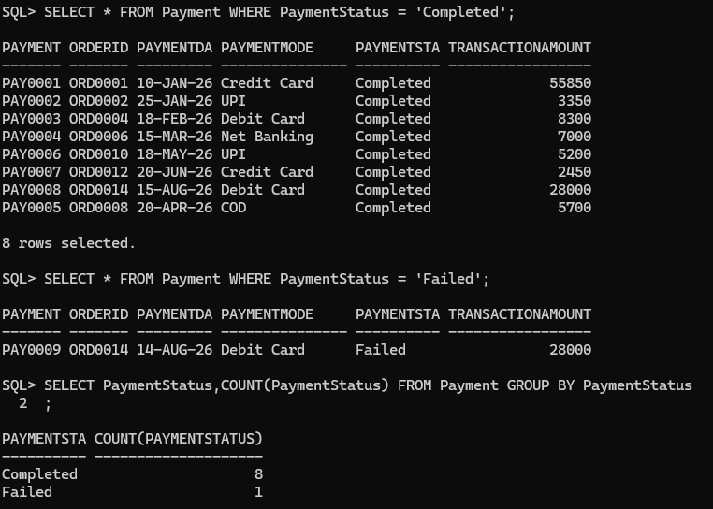

Analyze Payment Methods Used by Customers
Generate payment analysis reports. Report 1: Payment Mode Analysis Find:
  - Number of transactions using UPI.
  - Number of card payments.
  - Most preferred payment method.
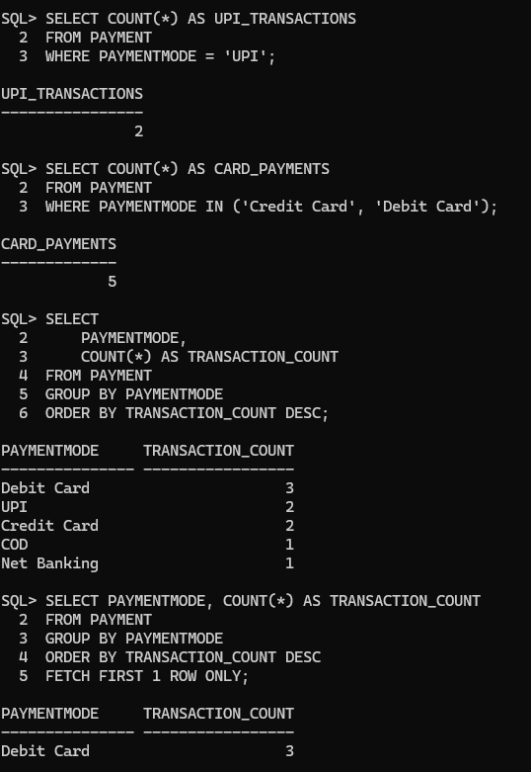

Report 2: Revenue Analysis

Find:
  - Total revenue generated.
  - Revenue by payment method.
  - Average transaction amount.
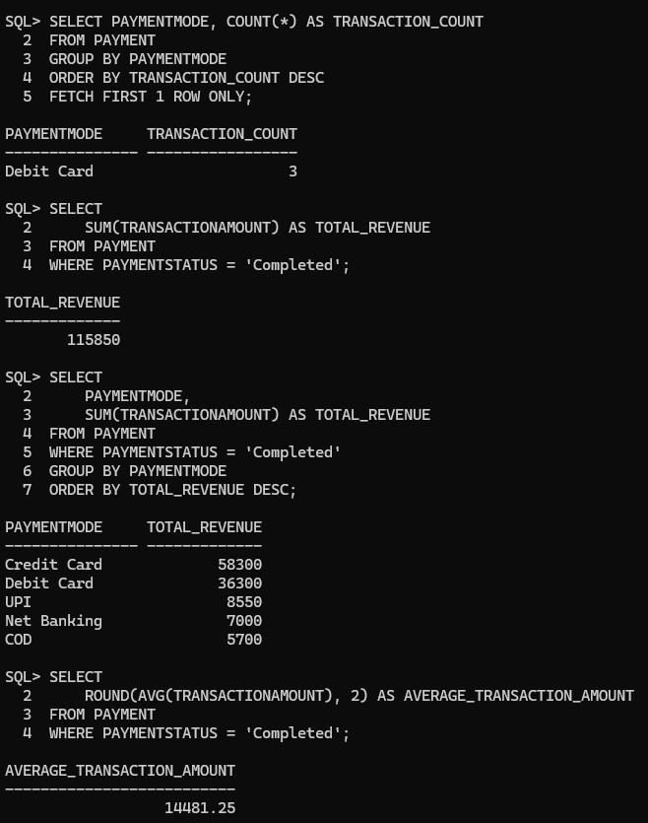

Report 3: Customer Payment History

Display:
  - Customer name
  - Order ID
  - Payment mode
  - Amount
  - Payment status
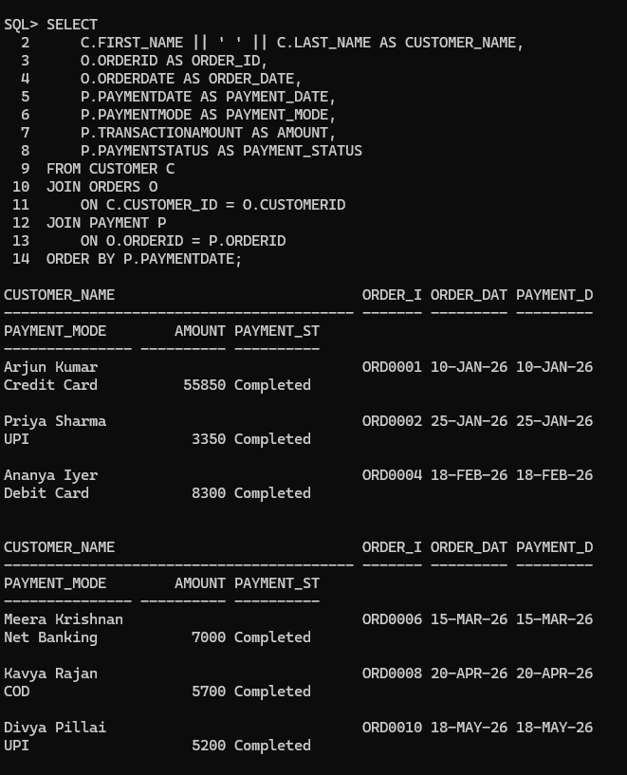
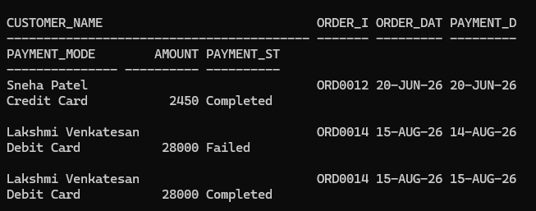

Payment Analysis:
